实验二：单例工厂模式

(1) 单例模式（必做80分）
建立一个JavaFX界面，不管创建多少次主席，都只能创建一个“毛泽东”对象，并验证获取的主席都是“毛泽东”。

1.1 UML图
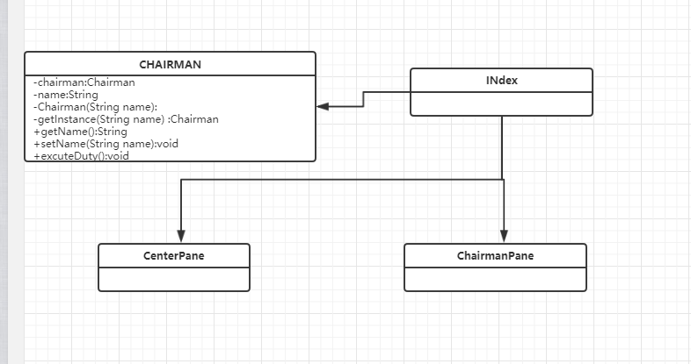

1.2 代码
Chairman.java
package cn.edu.scau.cmi.mayiming.singleton;

public class Chairman {

private static Chairman chairman;
private String name;

private Chairman(String name) {
this.name=name;
}

public static Chairman getInstance(String name) {
// Chairman chairman = null;
if (chairman == null) {
chairman=new Chairman(name);
return chairman;
} else
return chairman;

}

public String getName() {
return name;
}

public void setName(String name) {
this.name = name;
}

public void excuteOfDuty(){
System.out.println("同志们辛苦了");
}

}

Index.java
package cn.edu.scau.cmi.chengruyuan.singleton;

import javafx.application.Application;
import javafx.event.ActionEvent;
import javafx.event.EventHandler;
import javafx.geometry.Insets;
import javafx.scene.Scene;
import javafx.scene.control.Button;
import javafx.scene.control.Label;
import javafx.scene.layout.BorderPane;
import javafx.scene.layout.FlowPane;
import javafx.scene.layout.HBox;
import javafx.scene.layout.VBox;
import javafx.scene.text.Font;
import javafx.stage.Stage;

public class Index extends Application{

public static void main (String[] args) {
Application.launch(args);
}

@Override
public void start(Stage primaryStage) throws Exception {
BorderPane pane = new BorderPane();
Label topLabel = new Label("单例设计模式");
topLabel.setFont(Font.font(20));
pane.setTop(topLabel);
pane.setCenter(new CenterPane());

Scene scene = new Scene(pane);
primaryStage.setTitle("实验2");
primaryStage.setScene(scene);
primaryStage.show();
}

}

class ChairmanPane extends VBox {
public ChairmanPane (String id) {
this.setPrefWidth(200);
this.setPrefHeight(100);

Button btn = new Button("毛");
btn.setPrefHeight(60);
btn.setPrefWidth(100);

Label label = new Label(id);
label.setVisible(false);
label.setManaged(false);

this.getChildren().addAll(btn, label);

btn.setOnAction(new EventHandler<ActionEvent>() {

@Override
public void handle(ActionEvent event) {
label.setVisible(true);
label.setManaged(true);
}
});

}
}

class CenterPane extends HBox {
public CenterPane () {
this.setPrefHeight(800);
this.setPrefWidth(600);
VBox left = new VBox();
Button produceBtn = new Button("产生主席");
left.getChildren().addAll(produceBtn);

FlowPane flowPane = new FlowPane();
flowPane.setPadding(new Insets(15,15,15,15));

getChildren().addAll(left, flowPane);

produceBtn.setOnAction(new EventHandler<ActionEvent>() {

@Override
public void handle(ActionEvent event) {
Chairman chairmanInstance = Chairman.getInstance("毛主席");
flowPane.getChildren().add(new ChairmanPane(chairmanInstance.getName() + " \nhashCode: " +
chairmanInstance.hashCode()));
}
});

}
}

